Lab Guide Vol3 Module 05: SQL Injection

Scenario
SQL injection is the most common and devastating attack that attackers can use to take control of data-driven web applications and websites. It is a code injection technique that exploits a security vulnerability in a website or application’s software. SQL injection attacks use a series of malicious SQL (Structured Query Language) queries or statements to directly manipulate any type of SQL database. Applications often use SQL statements to authenticate users, validate roles and access levels, store, obtain information for the application and user, and link to other data sources. SQL injection attacks work when applications do not properly validate input before passing it to a SQL statement.
When attackers use tactics like SQL injection to compromise web applications and sites, the targeted organizations can incur huge losses in terms of money, reputation, and loss of data and functionality.
As an ethical hacker or penetration tester (hereafter, pen tester), you must possess sound knowledge of SQL injection techniques and be able protect against them in diverse ways such as using prepared statements with bind parameters, whitelist input validation, and user-supplied input escaping. Input validation can be used to detect unauthorized input before it is passed to the SQL query.
The labs in this module give hands-on experience in testing a web application against various SQL injection attacks.

Objective
The objective of this lab is to perform SQL injection attacks and other tasks that include, but are not limited to:
- Understanding when and how web applications connect to a database server in order to access data
- Performing a SQL injection attack on a MSSQL database
- Extracting basic SQL injection flaws and vulnerabilities
- Detecting SQL injection vulnerabilities

Overview of SQL Injection
SQL injection attacks can be performed using various techniques to view, manipulate, insert, and delete data from an application’s database. There are three main types of SQL injection:
- In-band SQL injection: An attacker uses the same communication channel to perform the attack and retrieve the results
- Blind/inferential SQL injection: An attacker has no error messages from the system with which to work, but rather simply sends a malicious SQL query to the database
- Out-of-band SQL injection: An attacker uses different communication channels (such as database email functionality, or file writing and loading functions) to perform the attack and obtain the results

Lab Tasks
Ethical hackers or pen testers use numerous tools and techniques to perform SQL injection attacks on target web applications. The recommended labs that will assist you in learning various SQL injection techniques include:
- Perform SQL injection attacks
  - Perform an SQL injection attack against MSSQL to extract databases using sqlmap
- Detect SQL injection vulnerabilities using various SQL injection detection tools
  - Detect SQL injection vulnerabilities using OWASP ZAP
- Perform SQL injection using AI
  - Perform SQL injection using ShellGPT

Lab 1: Perform SQL Injection Attacks
Lab Scenario
SQL injection is an alarming issue for all database-driven websites. An attack can be attempted on any normal website or software package based on how it is used and how it processes user-supplied data. SQL injection attacks are performed on SQL databases with weak codes that do not adequately filter, use strong typing, or correctly execute user input. This vulnerability can be used by attackers to execute database queries to collect sensitive information, modify database entries, or attach malicious code, resulting in total compromise of the most sensitive data.
As an ethical hacker or pen tester, to assess the systems in your target network, you should test relevant web applications for various vulnerabilities and flaws and then exploit those vulnerabilities to perform SQL injection attacks.
Lab Objectives
- Perform an SQL injection attack against MSSQL to extract databases using SQL map
Overview of SQL Injection
SQL injections can be used to implement the following attacks:
- Authentication bypass: An attacker logs onto an application without providing a valid username and password and gains administrative privileges
- Authorization bypass: An attacker alters authorization information stored in the database by exploiting SQL injection vulnerabilities
- Information disclosure: An attacker obtains sensitive information that is stored in the database
- Compromised data integrity: An attacker defaces a webpage, inserts malicious content into webpages, or alters the contents of a database
- Compromised availability of data: An attacker deletes specific information, the log, or audit information in a database
- Remote code execution: An attacker executes a piece of code remotely that can compromise the host OS
Task 1: Perform an SQL Injection Attack Against MSSQL to Extract Databases using sqlmap
sqlmap is an open-source penetration testing tool that automates the process of detecting and exploiting SQL injection flaws and taking over of database servers. It comes with a powerful detection engine, many niche features, and a broad range of switches—from database fingerprinting and data fetching from the database to accessing the underlying file system and executing commands on the OS via out-of-band connections.
You can use sqlmap to perform SQL injection on a target website using various techniques, including Boolean-based blind, time-based blind, error-based, UNION query-based, stacked queries, and out-of-band SQL injection.
In this task, we will use sqlmap to perform SQL injection attack against MSSQL to extract databases.
In this task, you will pretend that you are a registered user on the http://www.moviescope.com website, and you want to crack the passwords of the other users from the website’s database.
- Click Parrot Security to switch to the Parrot Security machine. Login using attacker/toor.
If a Question pop-up window appears asking you to update the machine, click No to close the window.
- Click the Mozilla Firefox icon from the menu bar in the top-left corner of Desktop to launch the web browser.
- Navigate to http://www.moviescope.com/. A Login page loads; enter the Username and Password as sam and test, respectively. Click the Login button.
If a Would you like Firefox to save this login for moviescope.com? notification appears at the top of the browser window, click Don’t Save.
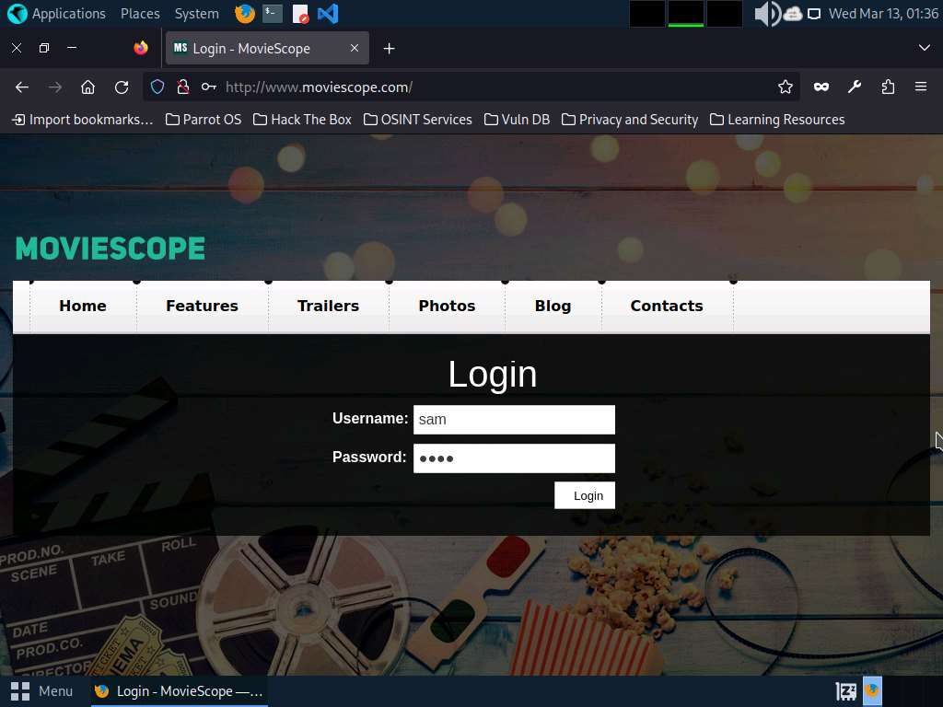
- Once you are logged into the website, click the View Profile tab on the menu bar and, when the page has loaded, make a note of the URL in the address bar of the browser.
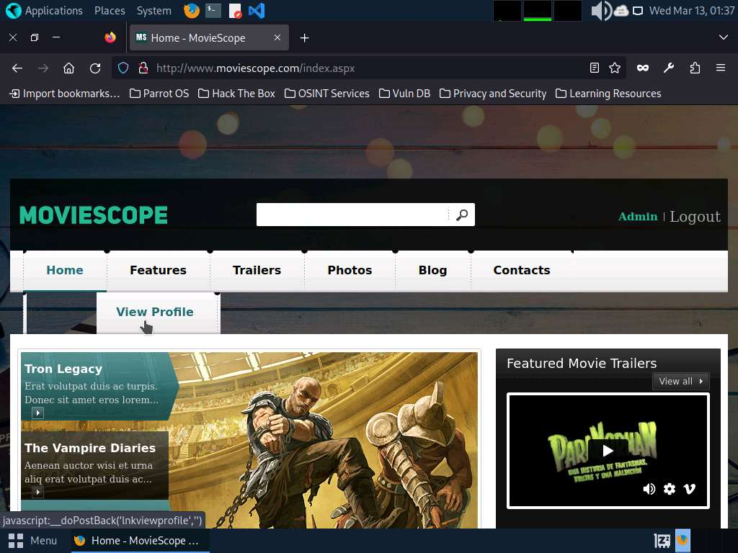
- Right-click anywhere on the webpage and click Inspect (Q) from the context menu, as shown in the screenshot.
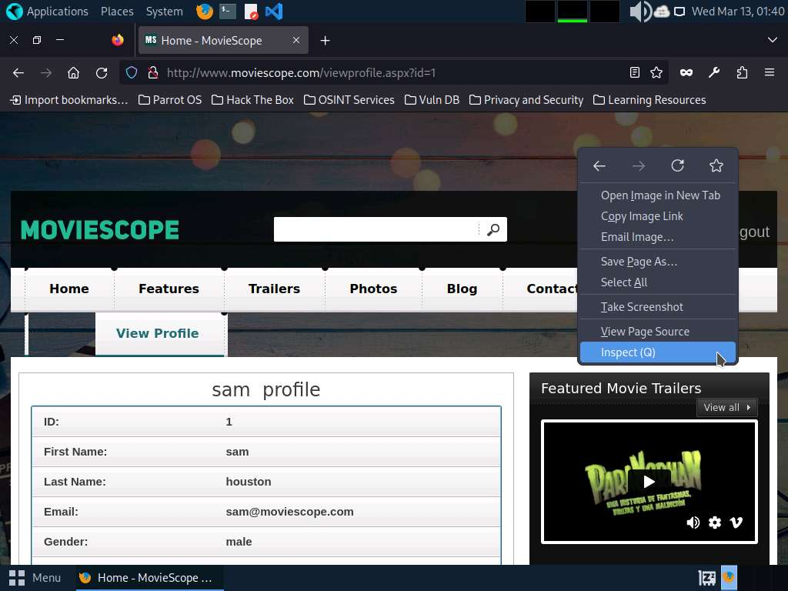
- The Developer Tools frame appears in the lower section of the browser window. Click the Console tab, type document.cookie in the lower-left corner of the browser, and press Enter.
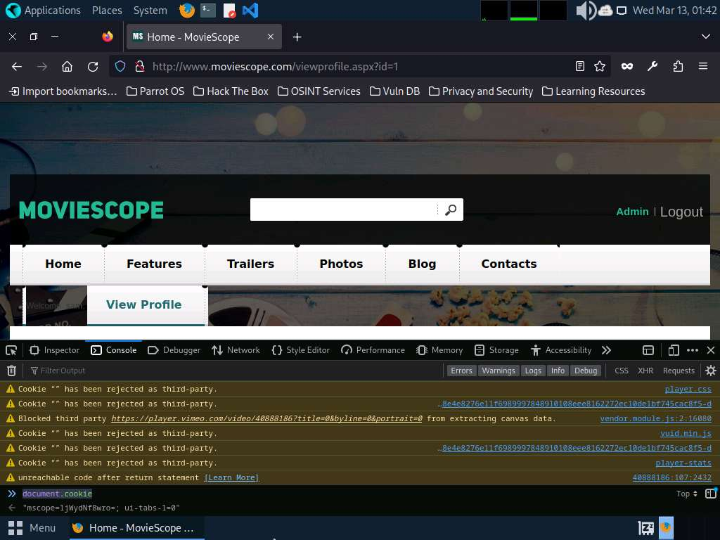
- Select the cookie value, then right-click and copy it, as shown in the screenshot. Minimize the web browser. Note down the URL of the web page.
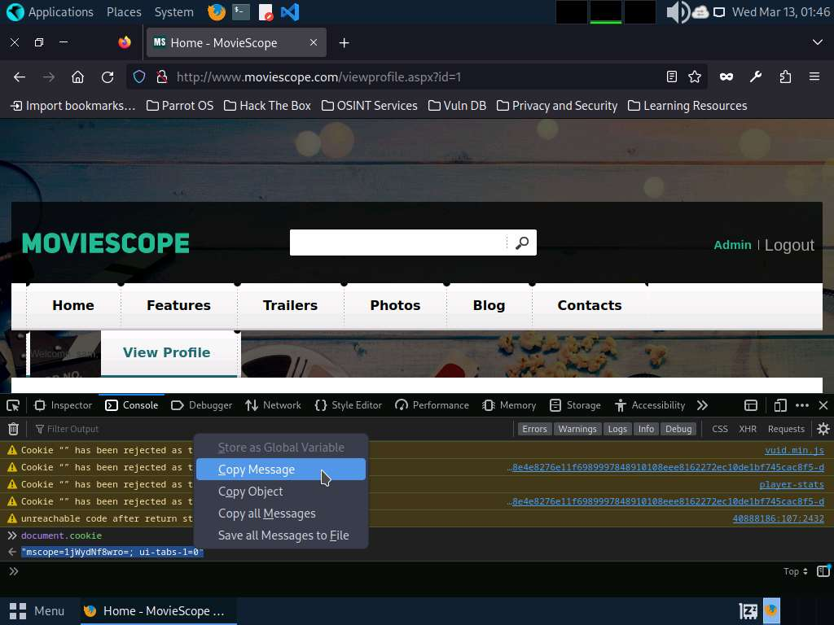
- Open a Terminal window and execute sudo su to run the programs as a root user (When prompted, enter the password toor).
The password that you type will not be visible.
- Run sqlmap -u "http://www.moviescope.com/viewprofile.aspx?id=1" --cookie="[cookie value that you copied in Step#7]" --dbs command.
In this query, -u specifies the target URL (the one you noted down in Step#7), --cookie specifies the HTTP cookie header value, and --dbs enumerates DBMS databases.
- The above query causes sqlmap to enforce various injection techniques on the name parameter of the URL in an attempt to extract the database information of the MovieScope website.
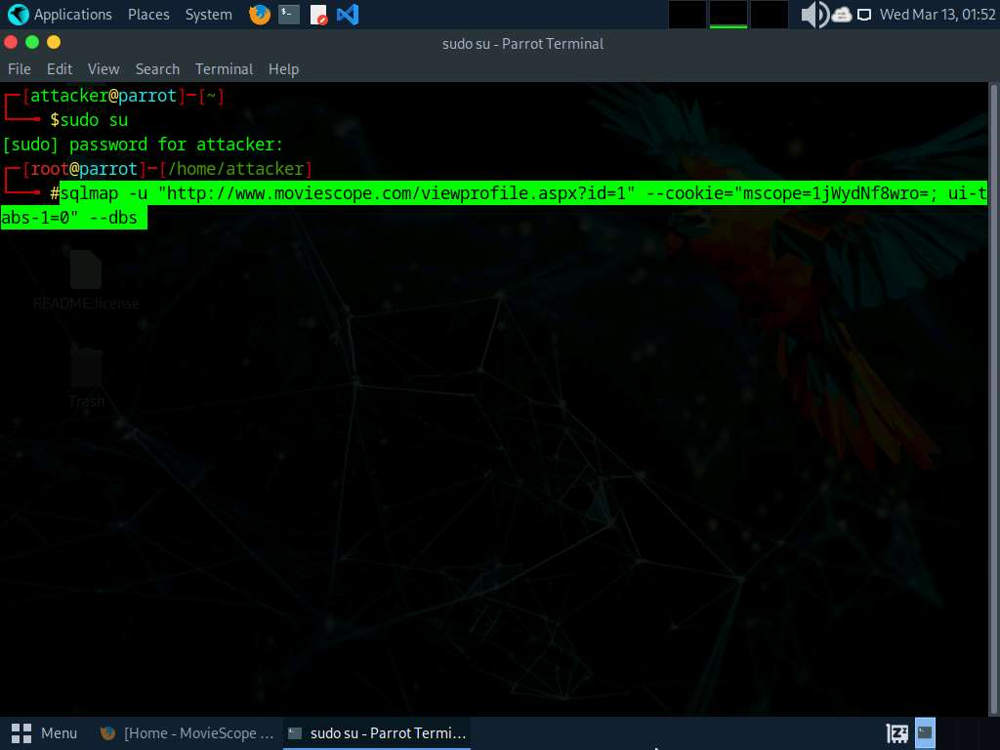
- If the message Do you want to skip test payloads specific for other DBMSes? [Y/n] appears, type Y and press Enter.
- If the message for the remaining tests, do you want to include all tests for ‘Microsoft SQL Server’ extending provided level (1) and risk (1) values? [Y/n] appears, type Y and press Enter.
- Similarly, if any other message appears, type Y and press Enter to continue.
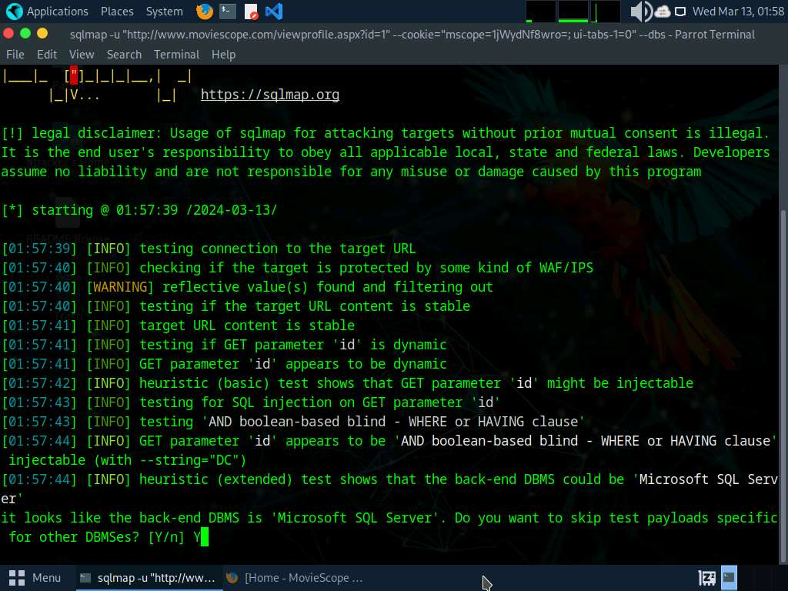
- sqlmap retrieves the databases present in the MSSQL server. It also displays information about the web server OS, web application technology, and the backend DBMS, as shown in the screenshot.
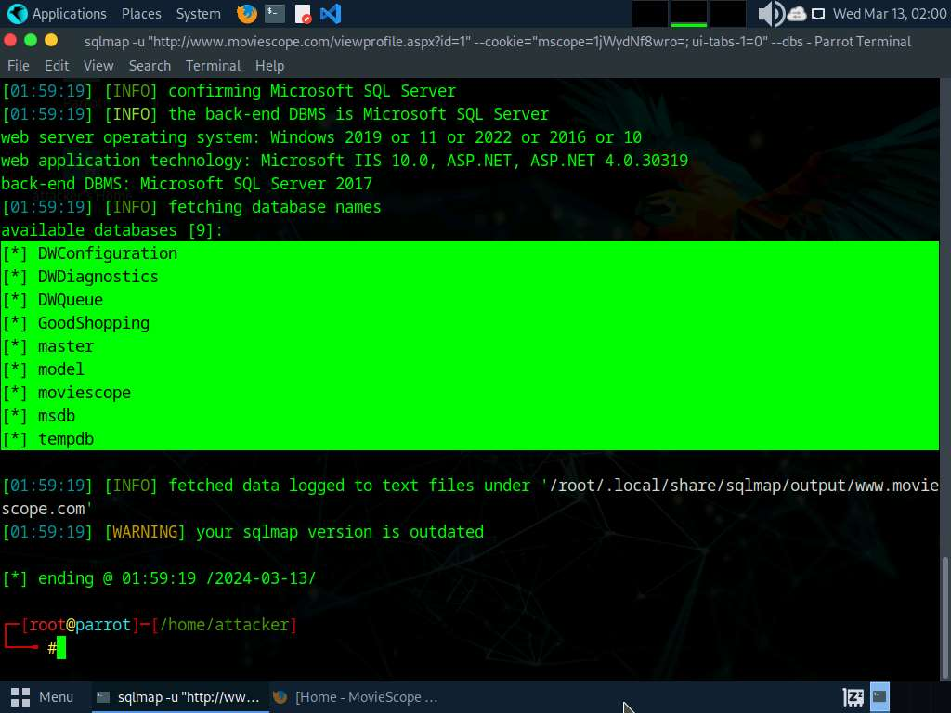
- Now, you need to choose a database and use sqlmap to retrieve the tables in the database. In this lab, we are going to determine the tables associated with the database moviescope.
- Run sqlmap -u "http://www.moviescope.com/viewprofile.aspx?id=1" --cookie="[cookie value which you have copied in Step#7]" -D moviescope --tables command.
In this query, -D specifies the DBMS database to enumerate and --tables enumerates DBMS database tables.
- The above query causes sqlmap to scan the moviescope database for tables located in the database.
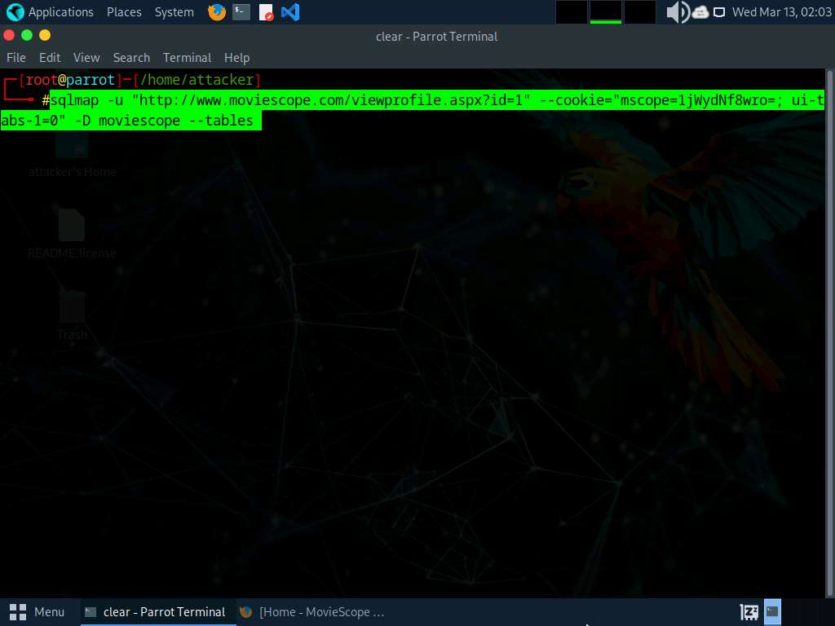
- sqlmap retrieves the table contents of the moviescope database and displays them, as shown in screenshot.
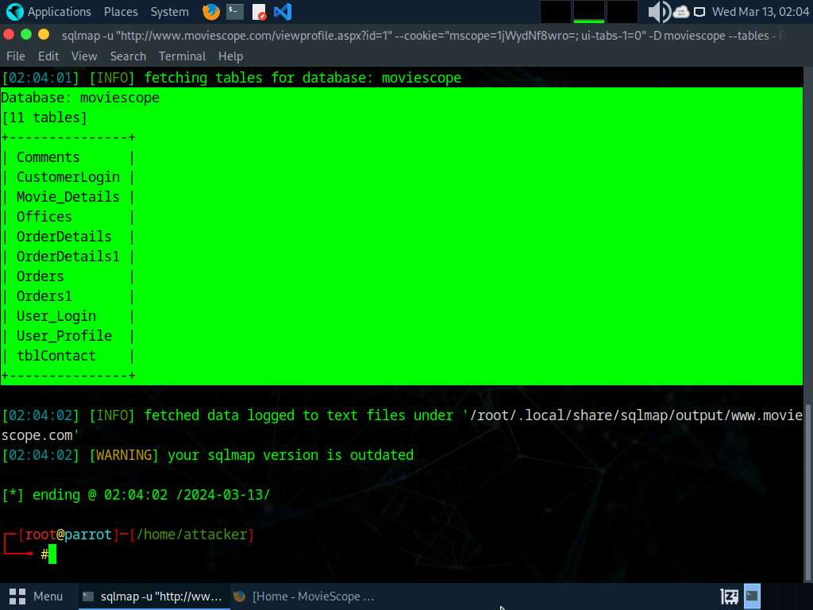
- Now, you need to retrieve the table content of the column User_Login.
- Run sqlmap -u "http://www.moviescope.com/viewprofile.aspx?id=1" --cookie="[cookie value which you have copied in Step#7]" -D moviescope -T User_Login --dump command to dump all the User_Login table content.
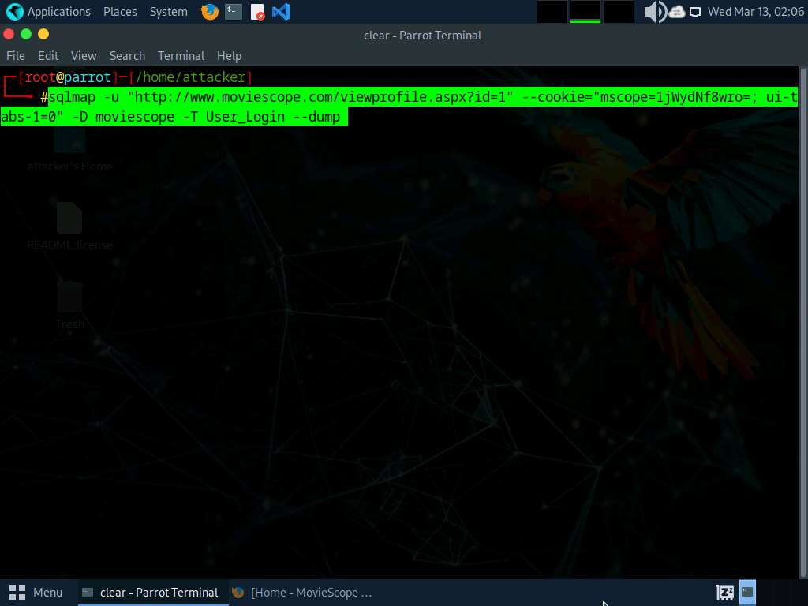
- sqlmap retrieves the complete User_Login table data from the database moviescope, containing all users’ usernames under the Uname column and passwords under the password column, as shown in screenshot.
- You will see that under the password column, the passwords are shown in plain text form.
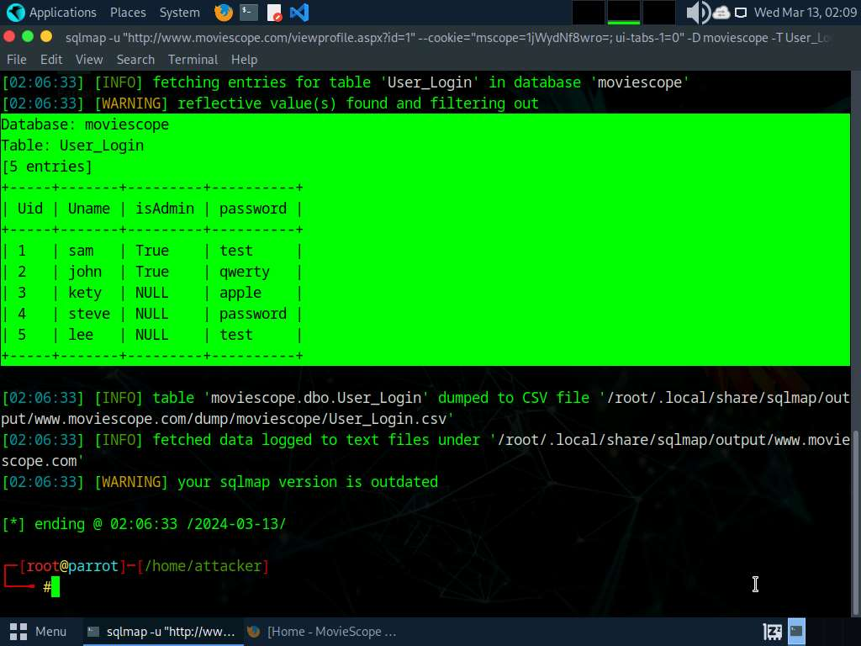
- To verify if the login details are valid, you should try to log in with the extracted login details of any of the users. To do so, switch back to the web browser, close the Developer Tools console, and click Logout to start a new session on the site.
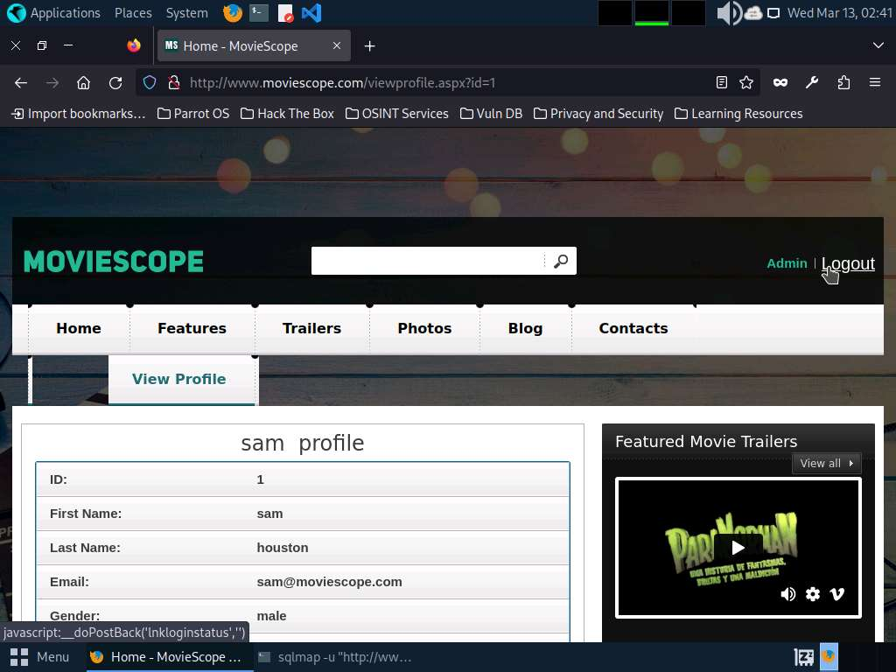
- The Login page appears; log in into the website using the retrieved credentials john/qwerty.
If a Would you like Firefox to save this login for moviescope.com? notification appears at the top of the browser window, click Don’t Save.
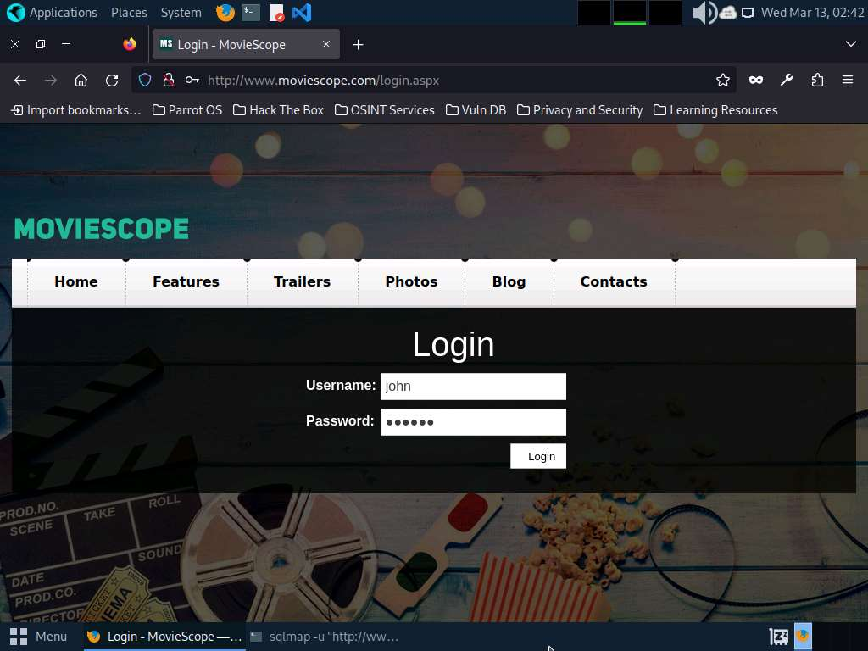
- You will observe that you have successfully logged into the MovieScope website with john’s account, as shown in the screenshot.
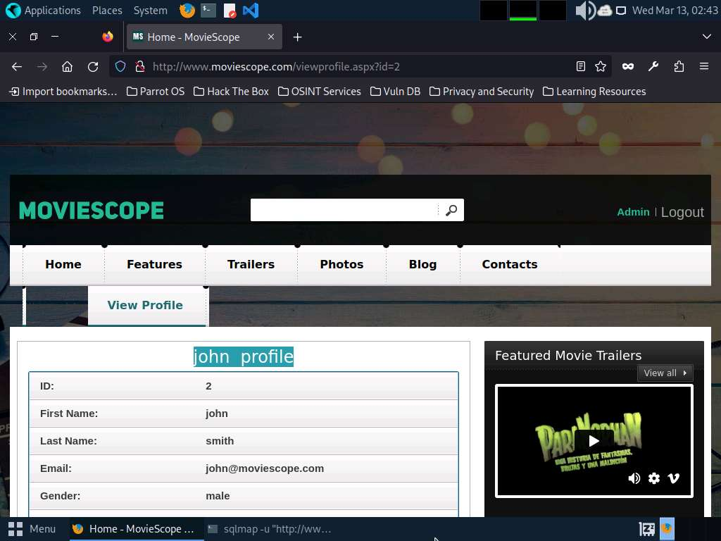
- Now, switch back to the Parrot Terminal window. Run sqlmap -u "http://www.moviescope.com/viewprofile.aspx?id=1" --cookie="[cookie value which you have copied in Step#7]" --os-shell.
In this query, --os-shell is the prompt for an interactive OS shell.
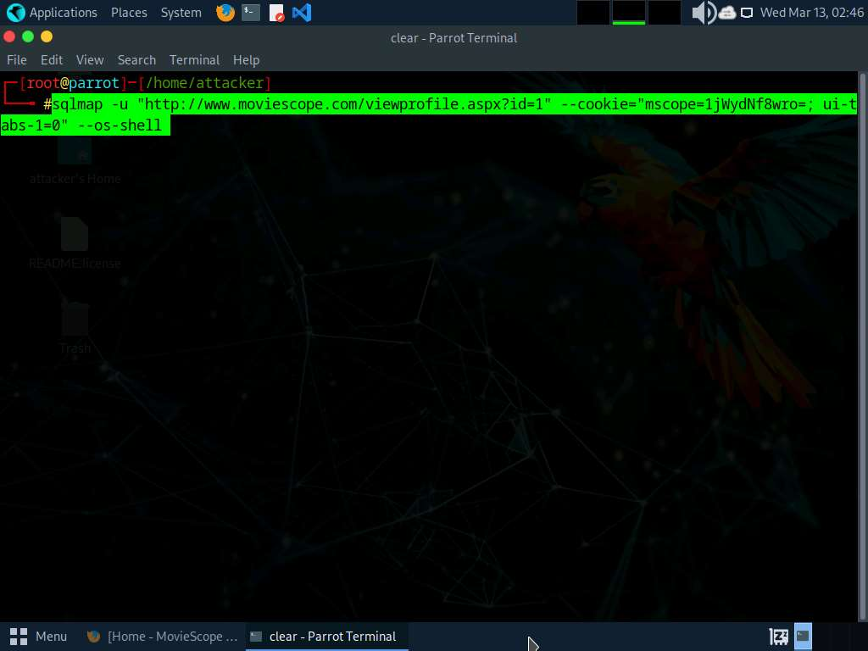
- If the message do you want sqlmap to try to optimize value(s) for DBMS delay responses appears, type Y and press Enter to continue.
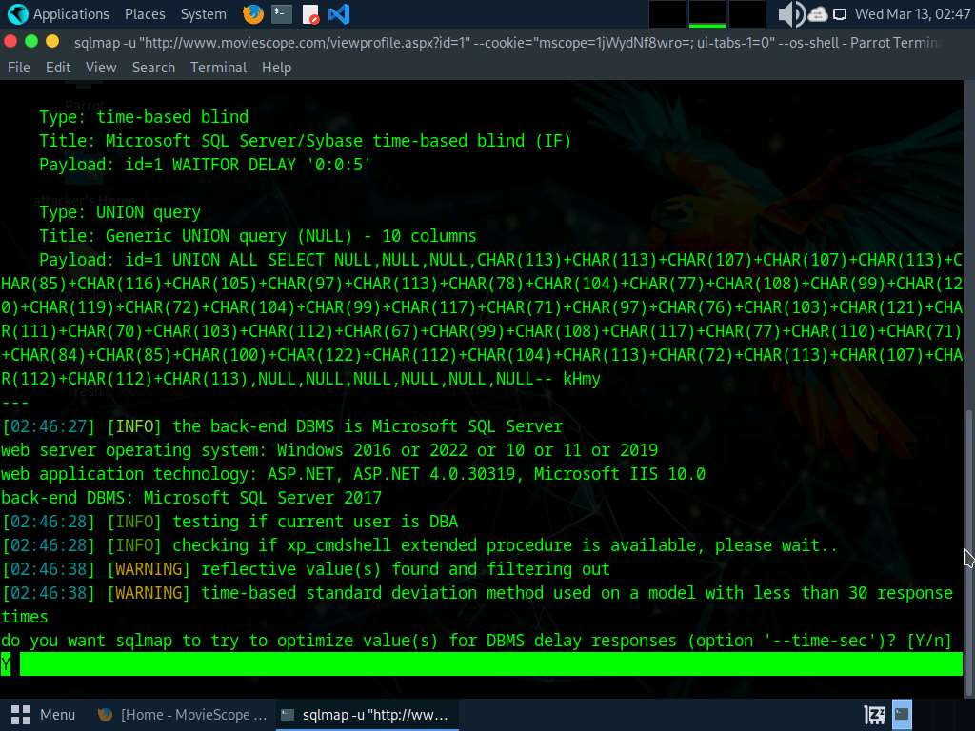
- Once sqlmap acquires the permission to optimize the machine, it will provide you with the OS shell. Type hostname and press Enter to find the machine name where the site is running.
- If the message do you want to retrieve the command standard output? appears, type Y and press Enter.
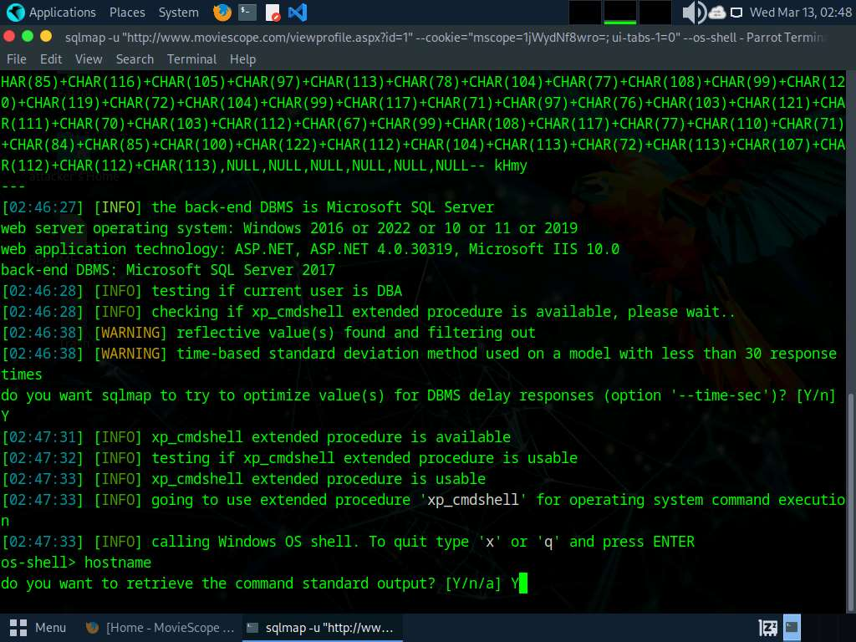
- sqlmap will retrieve the hostname of the machine on which the target web application is running, as shown in the screenshot.
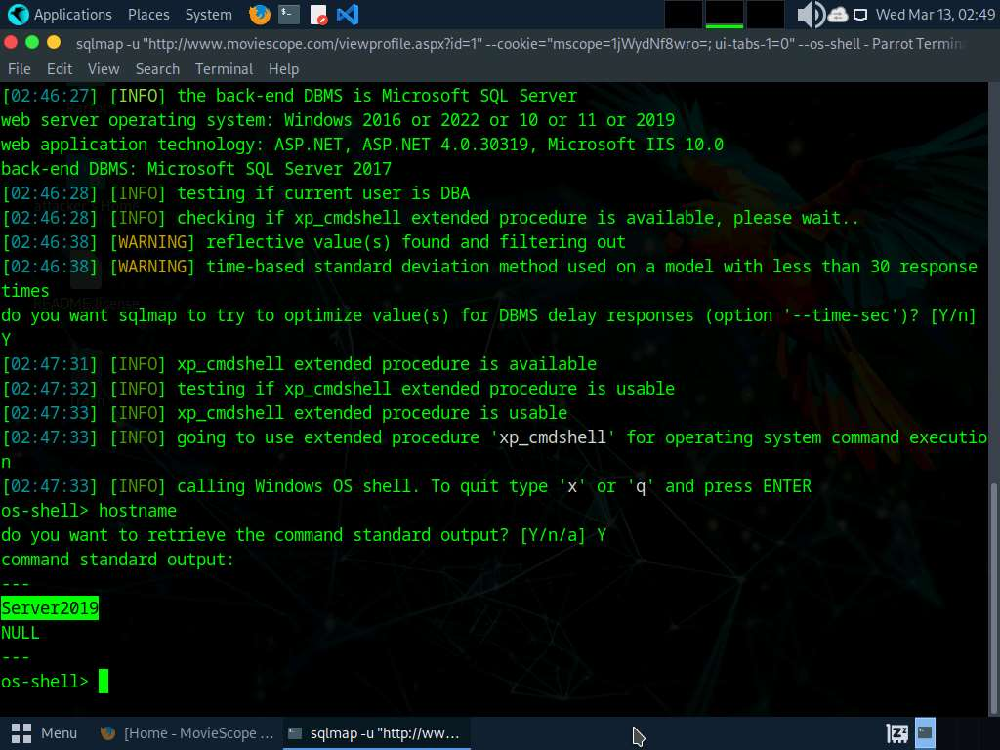
- Type TASKLIST and press Enter to view a list of tasks that are currently running on the target system.
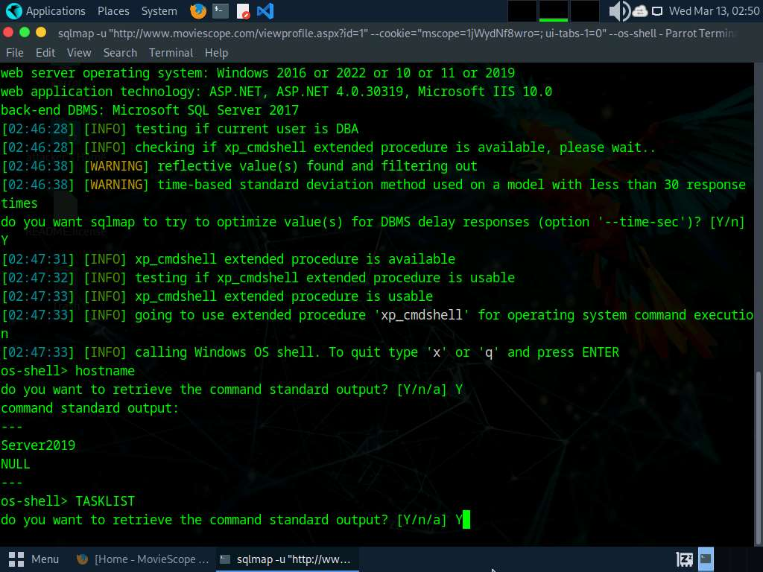
- If the message do you want to retrieve the command standard output? appears, type Y and press Enter.
- The above command retrieves the tasks and displays them under the command standard output section, as shown in the screenshots below.
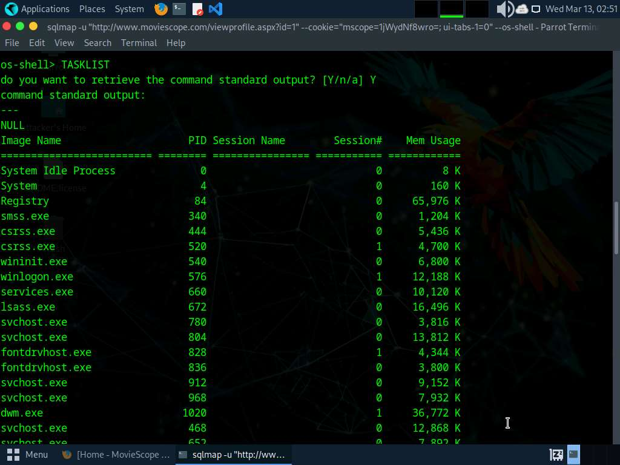
- Following the same process, you can use various other commands to obtain further detailed information about the target machine.
- To view the available commands under the OS shell, type help and press Enter.
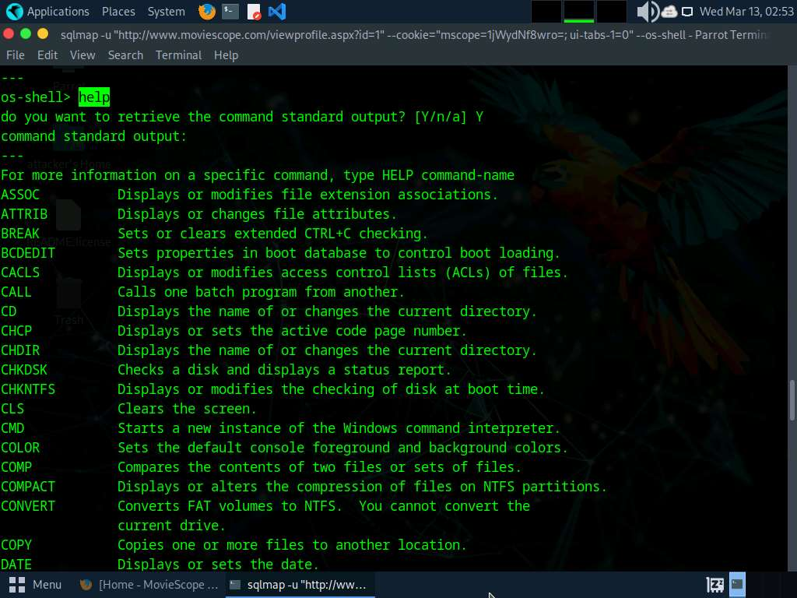
- This concludes the demonstration of how to launch a SQL injection attack against MSSQL to extract databases using sqlmap.
- Close all open windows and document all the acquired information.
- You can also use other SQL injection tools such as Mole (https://sourceforge.net), jSQL Injection (https://github.com), NoSQLMap (https://github.com), Havij (https://github.com) and blind_sql_bitshifting (https://github.com).
Question 15.1.1.1
Use the sqlmap tool to perform an SQL injection attack on the website www.moviescope.com to extract databases from the MSSQL database. Attempt to retrieve the table content of the column User_Login. Enter the password for the username steve.
Lab 2: Detect SQL Injection Vulnerabilities using Various SQL Injection Detection Tools
Lab Scenario
By now, you will be familiar with various types of SQL injection attacks and their possible impact. To recap, the different kinds of SQL injection attacks include authentication bypass, information disclosure, compromised data integrity, compromised availability of data and remote code execution (which allows identity spoofing), damage to existing data, and the execution of system-level commands to cause a denial of service from the application.
As an ethical hacker or pen tester, you need to test your organization’s web applications and services against SQL injection and other vulnerabilities, using various approaches and multiple techniques to ensure that your assessments, and the applications and services themselves, are robust.
In the previous lab, you learned how to use SQL injection attacks on the MSSQL server database to test for website vulnerabilities.
In this lab, you will learn how to test for SQL injection vulnerabilities using various other SQL injection detection tools.
Lab Objectives
- Detect SQL injection vulnerabilities using OWASP ZAP
Overview of SQL Injection Detection Tools
SQL injection detection tools help to discover SQL injection attacks by monitoring HTTP traffic, SQL injection attack vectors, and determining if a web application or database code contains SQL injection vulnerabilities.
To defend against SQL injection, developers must take proper care in configuring and developing their applications in order to make them robust and secure. Developers should use best practices and countermeasures to prevent their applications from becoming vulnerable to SQL injection attacks.
Task 1: Detect SQL Injection Vulnerabilities using OWASP ZAP
OWASP Zed Attack Proxy (ZAP) is an integrated penetration testing tool for finding vulnerabilities in web applications. It offers automated scanners and a set of tools that allow you to find security vulnerabilities manually. It is designed to be used by people with a wide range of security experience, and as such is ideal for developers and functional testers who are new to penetration testing.
In this task, we will use OWASP ZAP to test a web application for SQL injection vulnerabilities.
We will scan the www.moviescope.com website that is hosted on the Windows Server 2019 machine.
- Click Windows Server 2019 to switch to the Windows Server 2019 machine.
If you are logged out of the Windows Server 2019 machine, click Ctrl+Alt+Delete, and login with Administrator/Pa$$w0rd.
- Click windows Search icon, search for Zap 2.14.0 in the search bar and launch ZAP.
- OWASP ZAP initialized and a prompt that reads Do you want to persist the ZAP Session? appears; select the No, I do not want to persist this session at this moment in time radio button, and click Start.
If a Manage Add-ons window appears, close it.
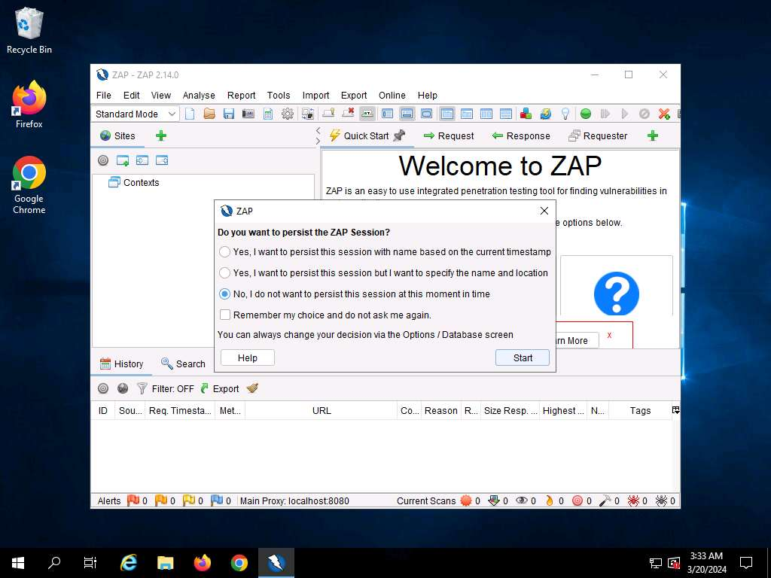
- The OWASP ZAP main window appears; under the Quick Start tab, click the Automated Scan option.
If OWASP ZAP alert pop-up appears, click OK in all the pop-ups.
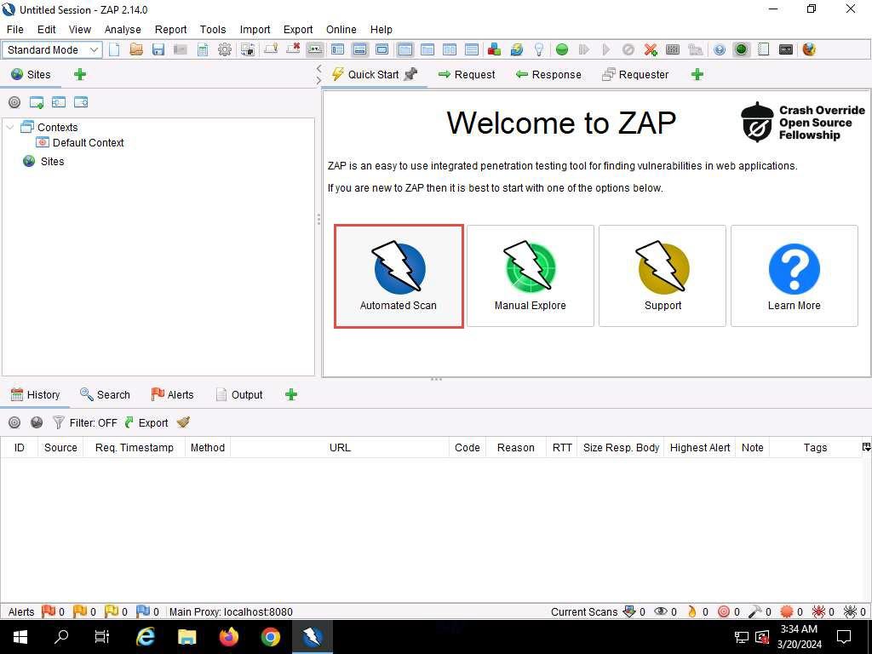
- The Automated Scan wizard appears; enter the target website in the URL to attack field (in this case, http://www.moviescope.com). Leave other options set to default, and then click the Attack button.
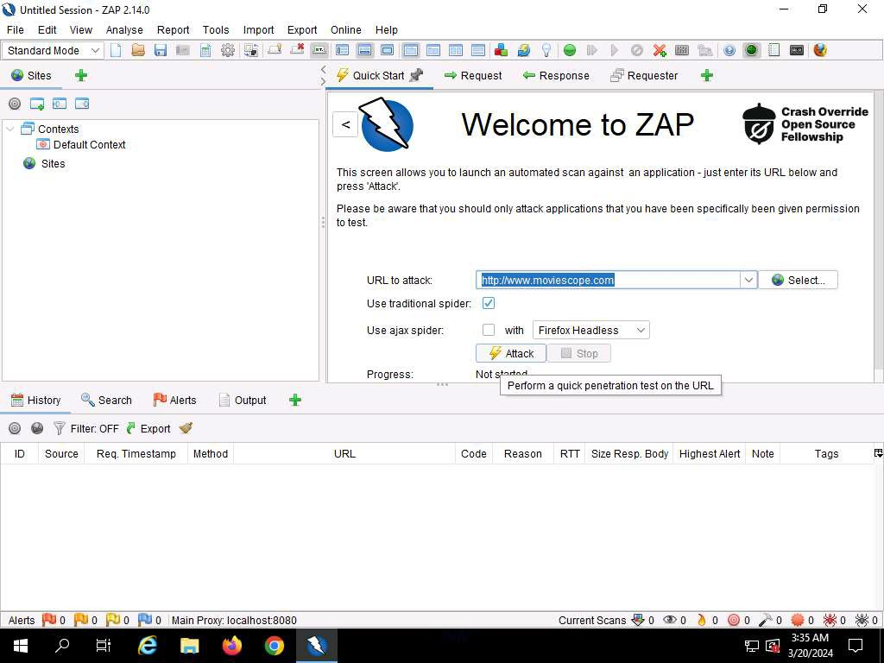
- OWASP ZAP starts performing Active Scan on the target website, as shown in the screenshot.
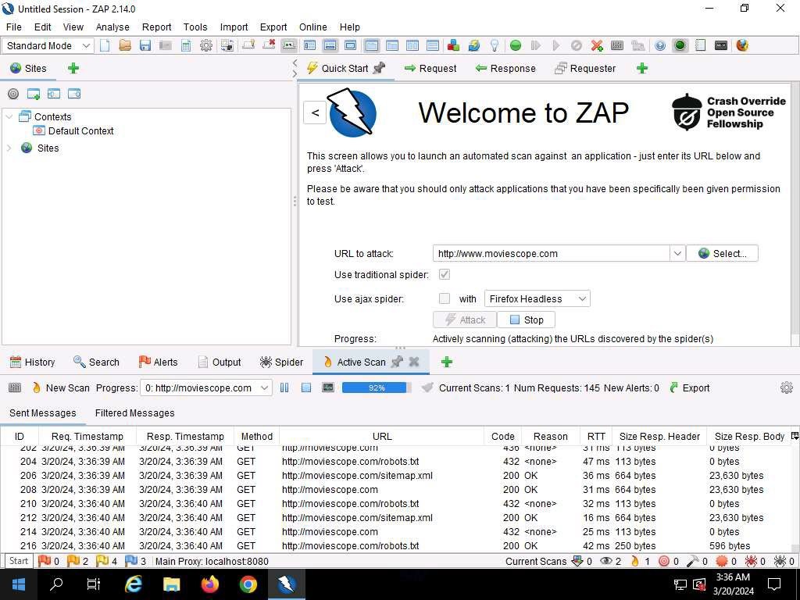
- After the scan completes, Alerts tab appears. You can observe the vulnerabilities found on the website under the Alerts tab.
The discovered vulnerabilities might differ when you perform this task.
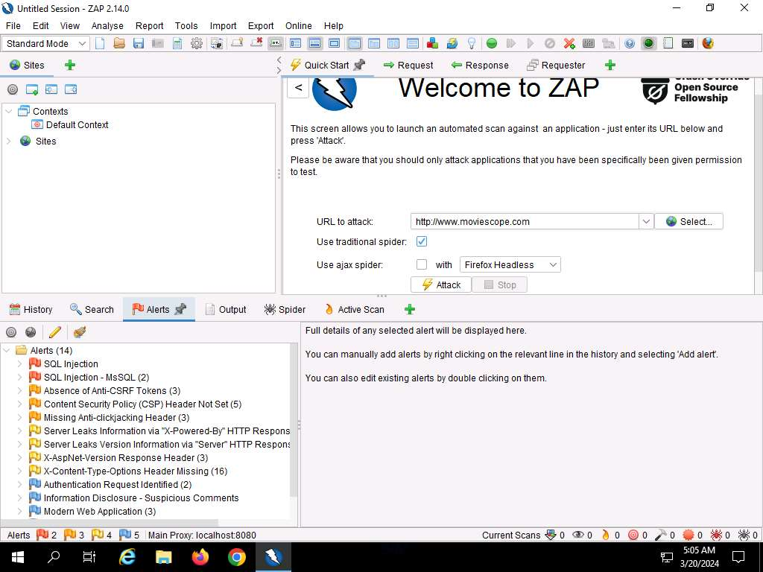
- Now, expand the SQL Injection vulnerability node under the Alerts tab.
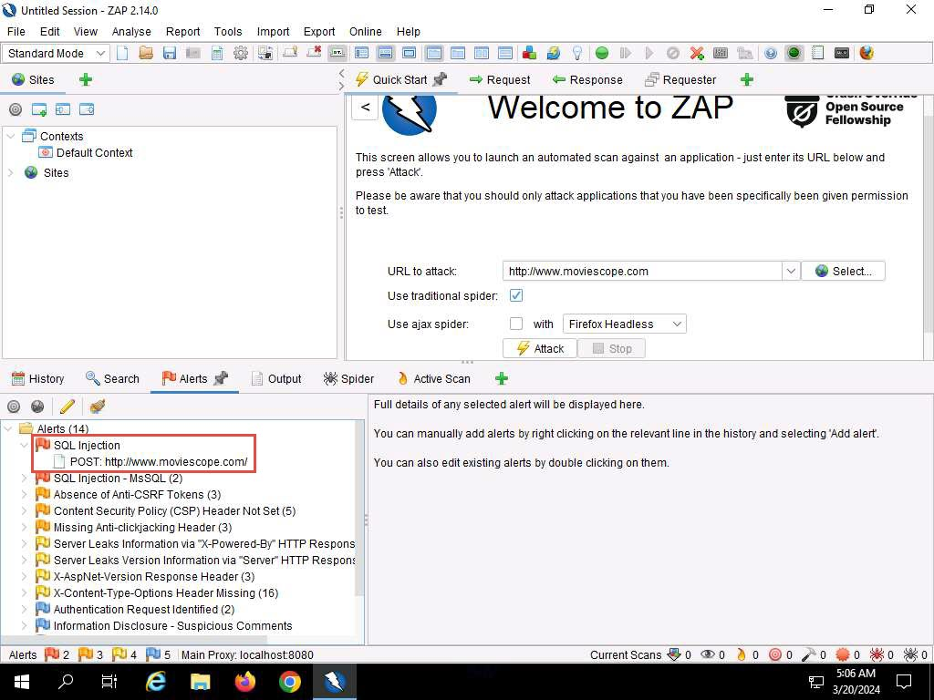
- Click on the discovered SQL Injection vulnerability and further click on the vulnerable URL.
- You can observe the information such as Risk, Confidence, Parameter, Attack, etc., regarding the discovered SQL Injection vulnerability in the lower right-bottom, as shown in the screenshot.
The risks associated with the vulnerability are categorized according to severity of risk as Low, Medium, High, and Informational alerts. Each level of risk is represented by a different flag color:
  - Red Flag: High risk
  - Orange Flag: Medium risk
  - Yellow Flag: Low risk
  - Blue Flag: Provides details about information disclosure vulnerabilities
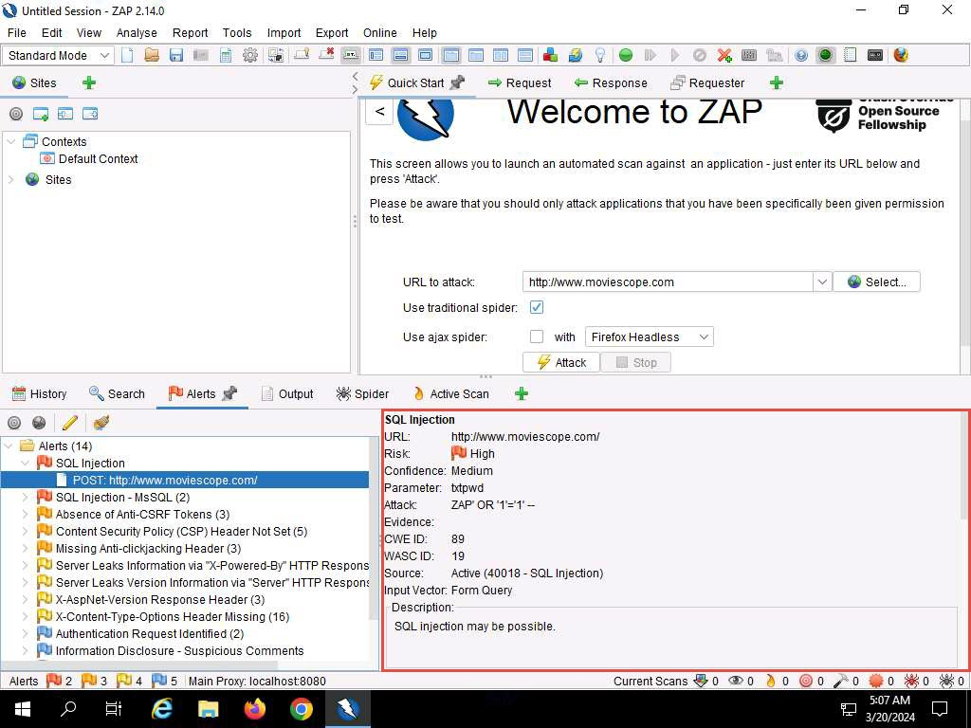
- Similarly, expand any other vulnerability (here, SQL Injection-MsSQL) node under the Alerts tab and further click on the vulnerable URLs.
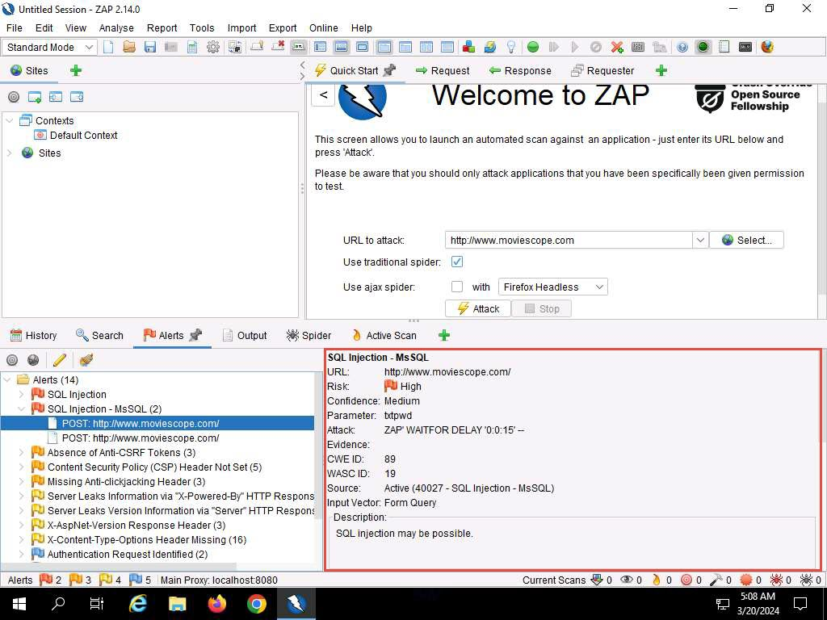
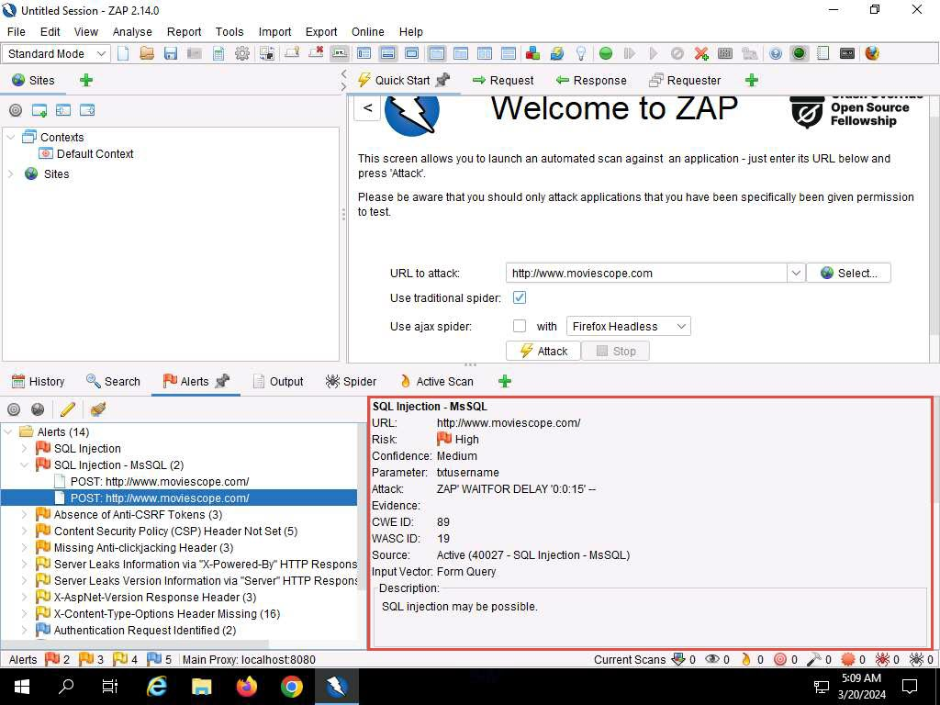
- This concludes the demonstration of how to detect SQL injection vulnerabilities using OWASP ZAP.
- Close all open windows and document all the acquired information.
- You can also use other SQL injection detection tools such as Damn Small SQLi Scanner (DSSS) (https://github.com), Snort (https://snort.org), Burp Suite (https://www.portswigger.net), HCL AppScan (https://www. hcl-software.com) etc. to detect SQL injection vulnerabilities.
Question 15.2.1.1
Use OWASP ZAP to test a web application (www.moviescope.com) for SQL injection vulnerabilities. Enter the CWE ID of the SQL injection vulnerability found in www.moviescope.com.
Question 15.2.1.2
Use OWASP ZAP to test a web application (www.moviescope.com) for SQL injection vulnerabilities. Enter the WASC ID of the SQL injection vulnerability found in www.moviescope.com
SQL Injection
Exit Lab
Lab 3: Perform SQL Injection using AI
Lab Scenario
As an ethical hacker or penetration tester, you must have a sound knowledge on the integration of AI technology in identifying and exploiting SQL injection vulnerabilities within web applications. You will leverage AI-generated payloads to enhance the efficiency and effectiveness of SQL injection attacks during penetration testing assessments.
Lab Objectives
- Perform SQL injection using ShellGPT
Overview of SQL Injection using AI
SQL injection with AI involves leveraging artificial intelligence to craft sophisticated injection payloads, automating the process of identifying and exploiting vulnerabilities in web applications. AI models generate context-aware SQL queries, enhancing penetration testing efficiency and effectiveness.
Task 1: Perform SQL Injection using ShellGPT
ShellGPT, an AI language model, can be utilized to assist in the exploration of SQL injection vulnerabilities within web applications. It can also assist in crafting malicious payloads or generating SQL queries.
Here, we will use ShellGPT to perform SQL injection on the target website.
The commands generated by ShellGPT may vary depending on the prompt used and the tools available on the machine. Due to these variables, the output generated by ShellGPT might differ from what is shown in the screenshots. These differences arise from the dynamic nature of the AI's processing and the diverse environments in which it operates. As a result, you may observe differences in command syntax, execution, and results while performing this lab task.
- Before starting this lab, click Parrot Security to switch to the Parrot Security machine and incorporate ShellGPT by following steps provided in Integrate ShellGPT in Parrot Security Machine.pdf.
Alternatively, you can follow the steps to integrate ShellGPT provided in Module 00: Integrate ShellGPT in Parrot Security Machine.
- In this lab we will use AI to perform SQL injection attack against MSSQL to extract databases.
In this task, you will pretend that you are a registered user on the http://www.moviescope.com website, and you want to crack the passwords of the other users from the website’s database.
- First we need to login to http://www.moviescope.com website and copy the cookie value; to do so follow Steps#2-7 from Task 2: Perform an SQL Injection Attack Against MSSQL to Extract Databases using sqlmap of Lab 1: Perform SQL Injection Attacks.
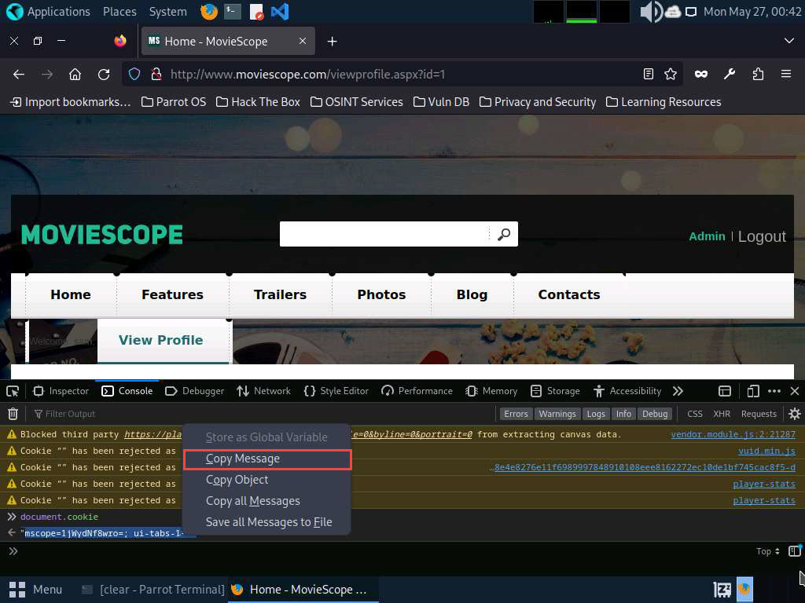
- We will now enumerate the database of the target website; to do so, switch to the terminal window and run sgpt --chat sql --shell “Use sqlmap on target url http://www.moviescope.com/viewprofile.aspx?id=1 with cookie value '[cookie value which you have copied in Step#3]' and enumerate the DBMS databases” command to scan the target website for SQL injection vulnerability and enumerate databases.
In the prompt, type E and press Enter to execute the command.
If Do you want to skip for other DBMSes? prompts , type Y and press Enter to execute the command.
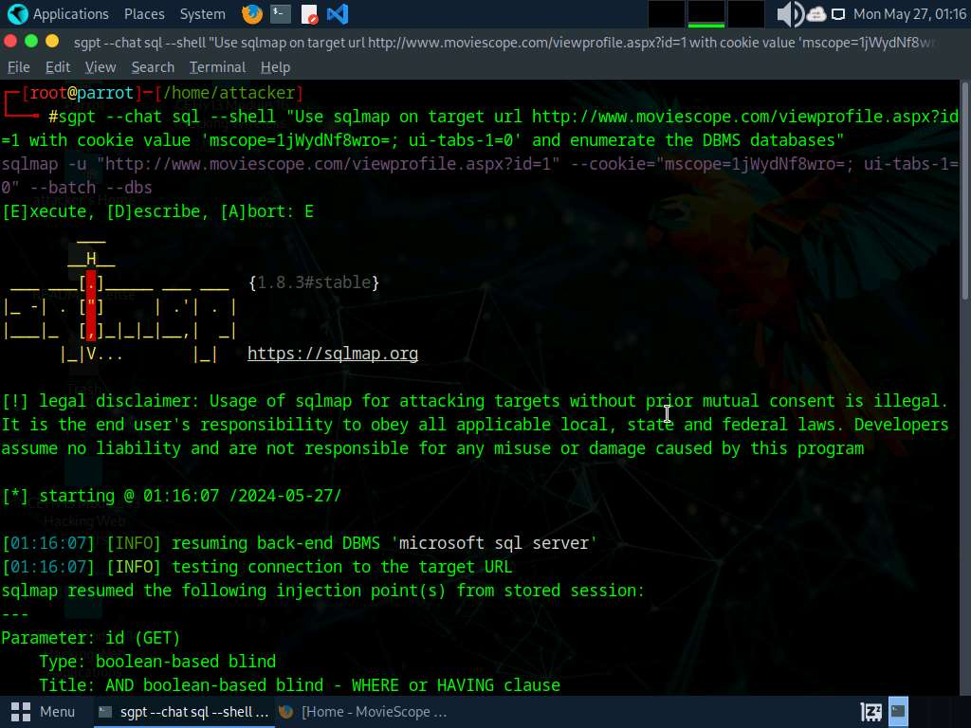
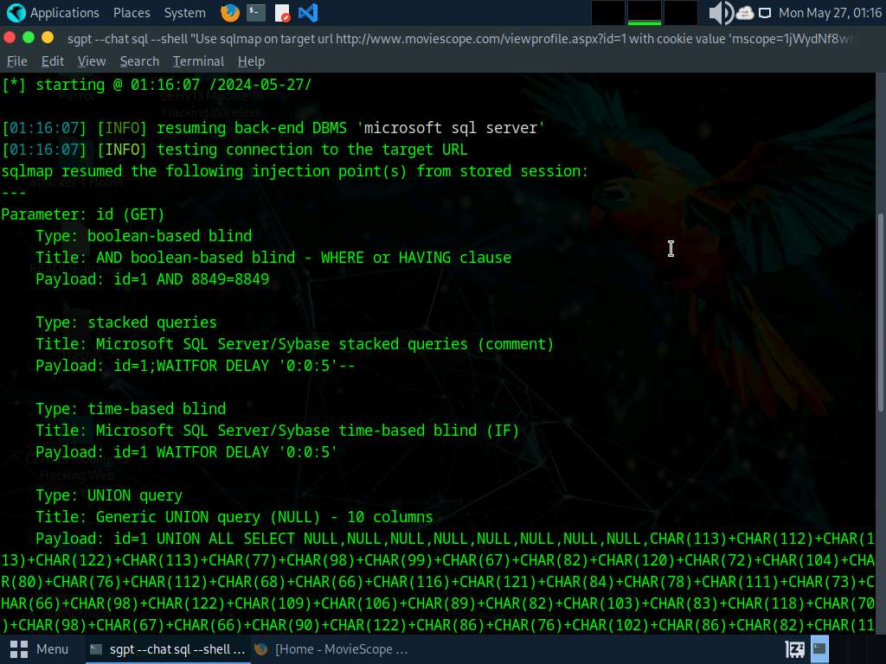
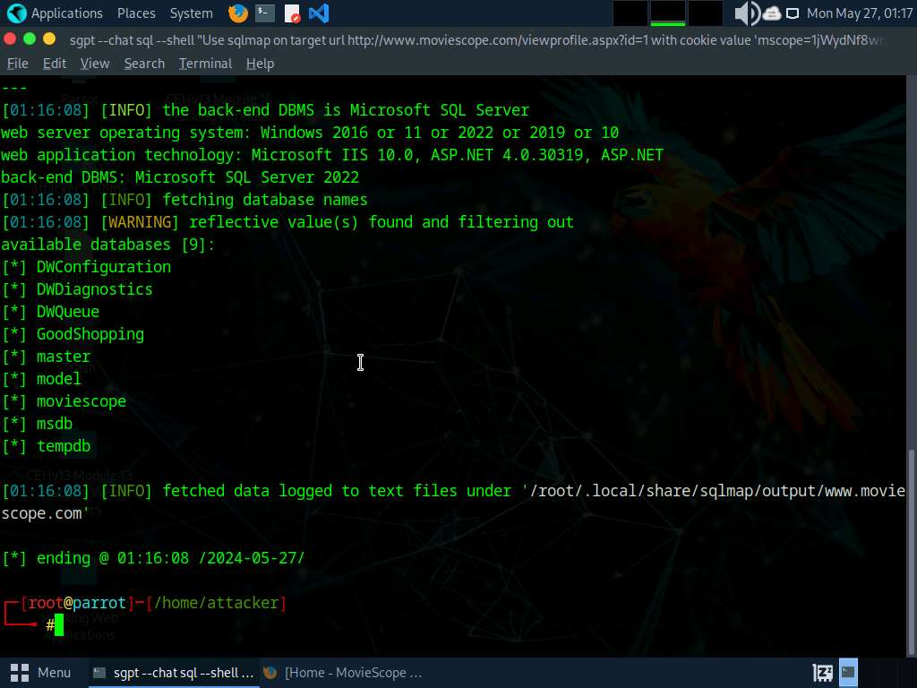
- We have successfully enumerated the databases from the target website. We will now enumerate the tables pertaining to the database moviescope. To do so run sgpt --chat sql --shell “Use sqlmap on target url http://www.moviescope.com/viewprofile.aspx?id=1 with cookie value '[cookie value which you have copied in Step#3]' and enumerate the tables pertaining to moviescope database" command.
In the prompt, type E and press Enter to execute the command.
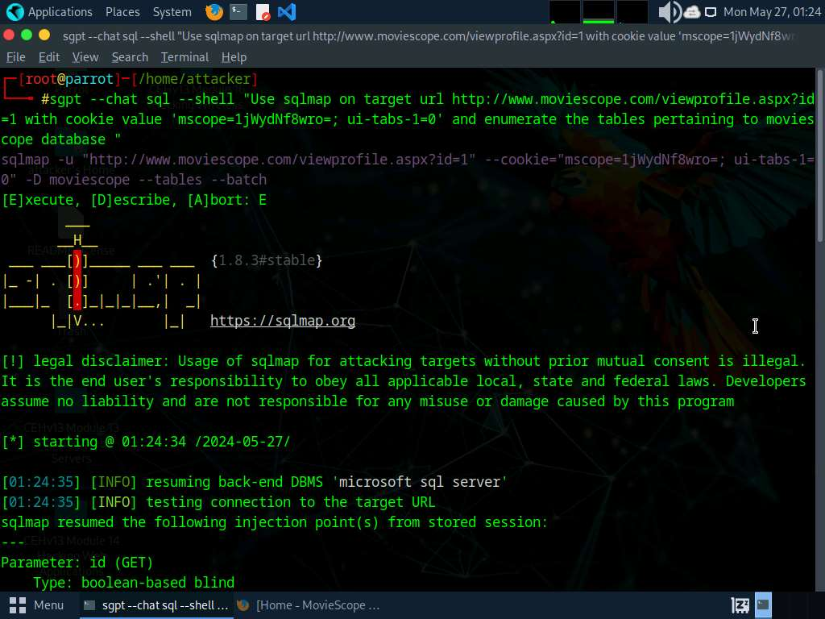
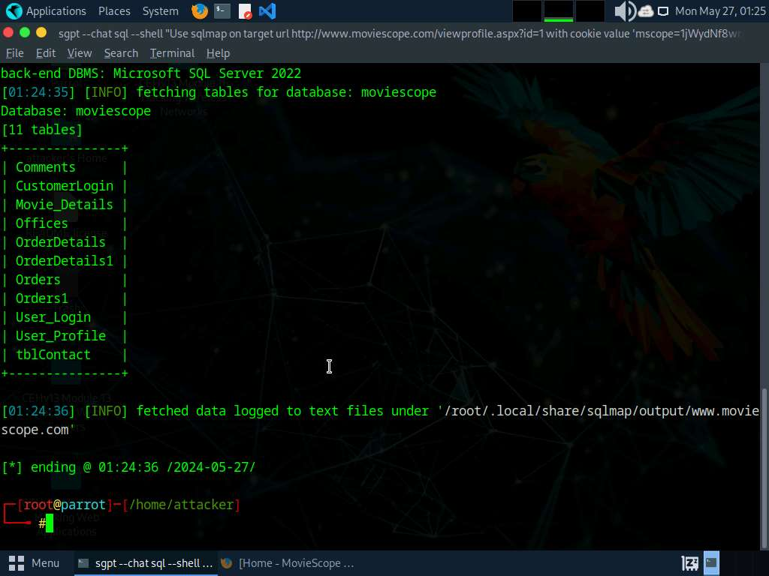
- After enumerating the database tables, we will dump the contents of the User_Login table to view the login information of the target website.
- Run sgpt --chat sql --shell “Use sqlmap on target url http://www.moviescope.com/viewprofile.aspx?id=1 with cookie value '[cookie value which you have copied in Step#3]' and retrieve User_Login table contents from moviescope database" command.
In the prompt, type E and press Enter to execute the command.
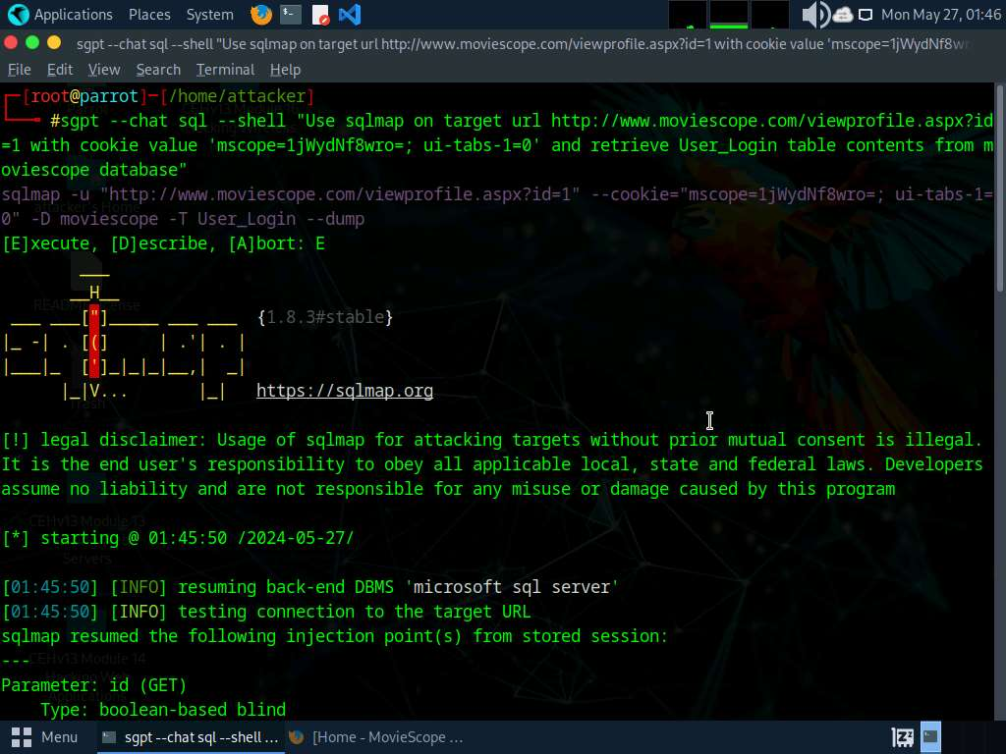
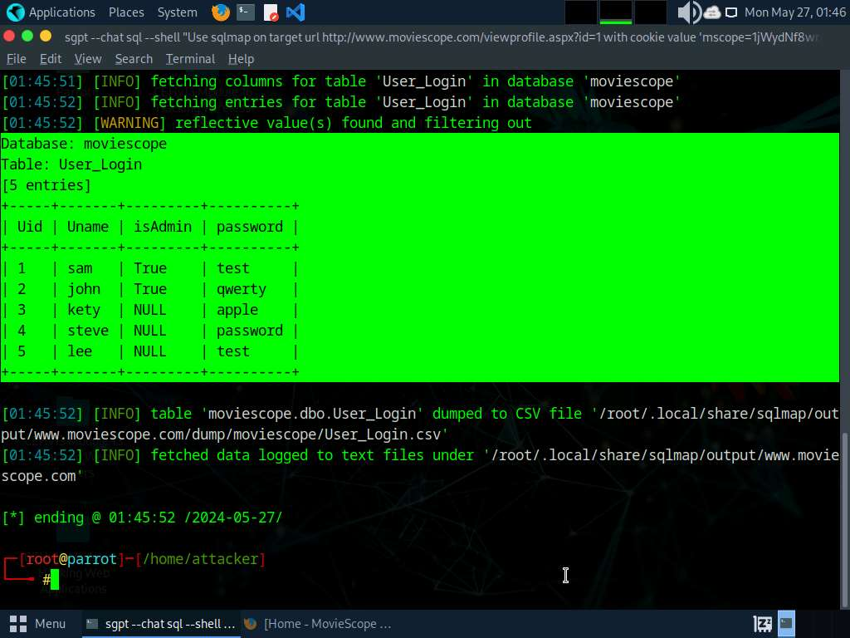
- Sqlmap retrieves the complete User_Login table data from the database moviescope, containing all users’ usernames under the Uname column and passwords under the password column, as shown in screenshot.
- You will see that under the password column, the passwords are shown in plain text form.
- To verify if the login details are valid, you should try to log in with the extracted login details of any of the users. To do so, switch back to the web browser, close the Developer Tools console, and click Logout to start a new session on the site.
- The Login page appears; log in into the website using the retrieved credentials steve/password.
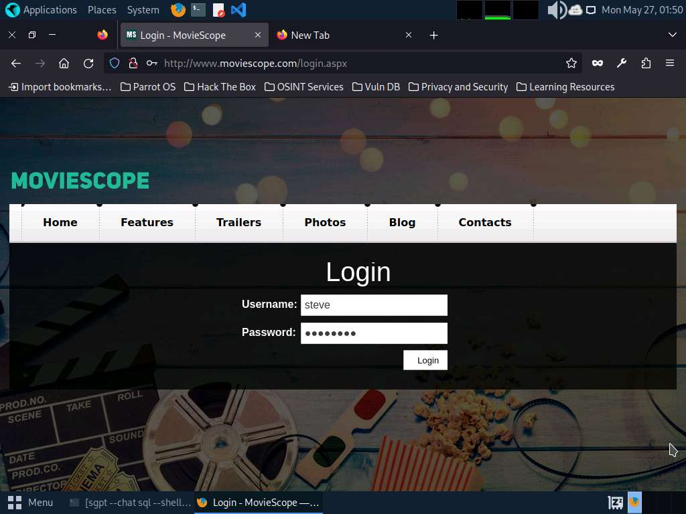
- You will observe that you have successfully logged into the MovieScope website with Steve's account, as shown in the screenshot.
If a Would you like Firefox to save this login for moviescope.com? notification appears at the top of the browser window, click Don’t Save.
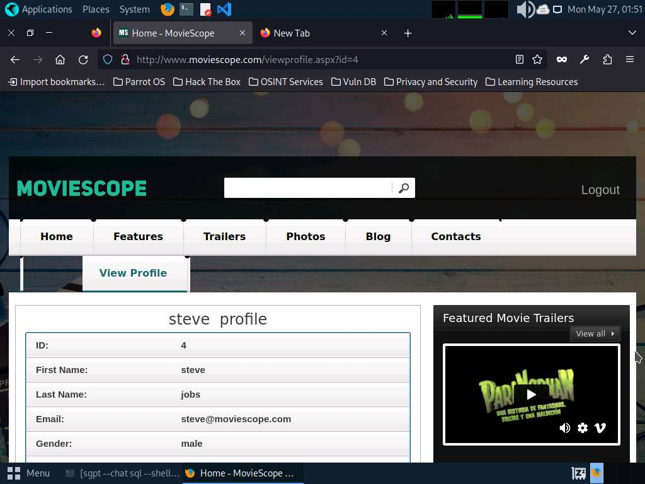
- Apart from the aforementioned commands, you can further explore additional options within the ShellGPT tool and utilize various other tools to perform SQL injection attacks on the target website.
- This concludes the demonstration of performing SQL injection on the target website using ShellGPT.
- Close all open windows and document all the acquired information.
Question 15.3.1.1
Write a ShellGPT prompt and execute it on Parrot Security machine to perform SQL injection using sqlmap tool on http://www.moviescope.com website. Enter the password of the user lee that was retrieved using SQL Injection.

